**Developer report**

**Title: ATM Security system using Raspberry pi.**

**Title ID:** TK8164

**Objective of the Project**: The theme of the project is we need to identify the ATM theft detection by using Fingerprint validation and as well as card less transaction. First user need to validate his finger print by using FP sensor. If the FP is valid then it will get an OTP to his registered mobile number. He need to enter the correct OTP then it will treat as valid user, or else it will treat as invalid user. If system identifies the invalid user then it will capture his face send attachment to corresponding bank email to take further action.

**Development Procedure:**

Step -1: Install raspberry pi OS (NOOBS) by following installation guidelines.

Step-2: Install python 3 by enter the command in terminal window ***sudo apt-get install idle3***

Step-3: Install required python libraries by enter the command in the terminal window

Finger print library -***sudo pip3 install pyfingerprint***

lcd- ***sudo pip3 install adafruit-blinka***

***sudo pip3 install adafruit-circuitpython-charlcd***

Step -4: copy all the codes in this location **Z:\COMMON FOLDER\EMBEDDED SOP\atm using fp** and paste in raspberry pi.

Step -5: open python3 idle and create a new file and paste the fp_enroll.txt code in that new file and save the file with the name of **fp_enroll.py**

Step -6: open python3 idle and create a new file and paste the fp_delete.txt code in that new file and save the file with the name of **fp_delete.py**

Step -7: open python3 idle and create a new file and paste the keypad.txt code in that new file and save the file with the name of **keypad.py**

Step -8: open python3 idle and create a new file and paste the main code.txt code in that new file and save the file with the name of **main code.py .**And edit your email id and passwords and receiver email id.

Step-9: connect the finger print sensor to UART pins in raspberrypi

Step -10: connect the LCD interacting with raspberry pi

* lcd_rs = gpio 7
* lcd_en = gpio 8
* lcd_d4 = gpio 25
* lcd_d5 = gpio 11
* lcd_d6 = gpio 9
* lcd_d7 = gpio 10

Step-11: key pad interfacing with raspberry pi.

* ROW pins = GPIO 21, GPIO 20, GPIO 16, GPIO 26
* COLUMN pins = GPIO 19, GPIO 13, GPIO 6

Step – 12: connect the web cam to raspberry pi usb port.

**Execution Procedure:**

***Steps for enroll:***

* step1: run the /home/pi/fp_enroll.py code and enroll your finger. it will generate an finger print ID note down that ID.
* step2: register your account in this url *http://atm.dbandroid.online/register.php*
* step3: fill up all valid details (a/c no, mobile, etc.,)click on submit. Your id will be register successfully.

***Steps for delete:***

* step1: run the /home/pi/fp_delete.py code and enter the id you want to delete.

***Steps for main code:***

* step1: run the /home/pi/maincode.py
* step2: place valid finger on the fp scanner
* step3: if the valid id found you will get OTP for your mobile
* step4: enter the valid OTP
* step5: if OTP is invalid mail alert will be sent with an image attachment.

**Reference Links:**

<https://learn.adafruit.com/drive-a-16x2-lcd-directly-with-a-raspberry-pi/python-code>

<https://pypi.org/project/pyfingerprint/>

**Trouble Shooting:**

While finger print enroll make sure you need to place your finger correctly and while submitting your details in online make sure you need to enter correct finger print ID

**Output Screenshots:**

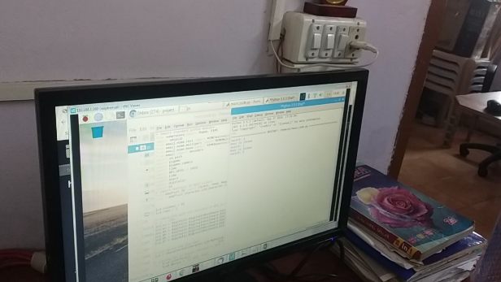 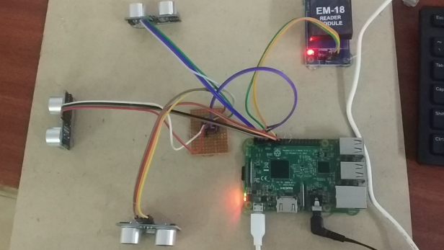

**Note: Above images or other project screen shorts for reference I placed.**

**Extension Idea:** For extension we need to validate the user ID by using his face recognition.